Mobile App Development

B8IT120

Develop a mobile app for Android using native and / or hybrid technologies

Anne-Marie McNamara

10370678

## Topic and objectives of your Mobile Application

This app was designed to be an app where the user can log in and see the locations of bike stations around Dublin. There is a gallery where photos of the location of bike stations around Dublin are situated. There is also a map which shows the user where they are, so they can input the name of the bike station they want to use and it should show up on Google maps.

I took inspiration from these apps:

* Dubikes
* Cycle Planner
* Get Around

I particularly liked the three tab layout of the Get Around app:

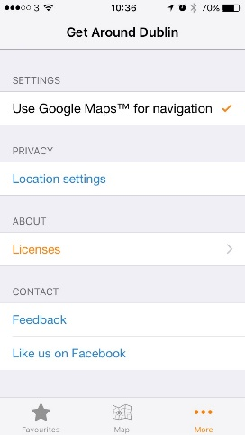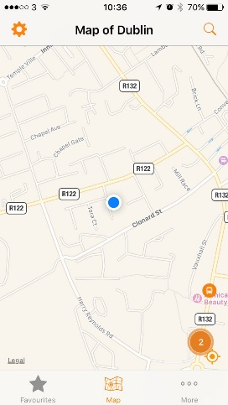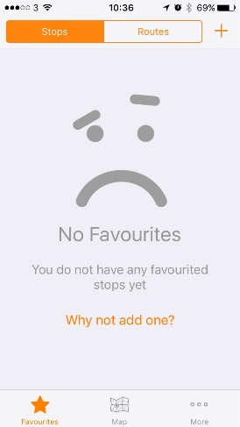

The tab it opens on is the favourites, then the next tab is the map and the final tab is the extra content. I liked that the tabs are at the bottom of the screen, not the top. I wanted to put this in my app, but since I had to put in a login first, I couldn’t open my app on any of the tabs. I had to figure out how to connect the login to the tabs.

I used the code from the Coursera Tabwidget app which has the tabs at the top.

## Target Audience

The target audience is people who have an android phone and use the community bike scheme in Dublin.

## Rationale behind Development Approach (hybrid or native)

I used a native approach with Android Studio as I wasn’t taught the hybrid approach.

## Description of the cloud services used to manage back end (registration, login, profiles, image storage)

I used firebase for the login and registration. I had a lot of problems with it and couldn’t get it to run at any time. I didn’t know of any other cloud based options to go with so I was stuck with malfunctioning firebase. I repeatedly checked online for answers and followed some suggestions from stack overflow but ultimately it defeated me.

## Differences between prototype and final deliverable and an explanation of the differences

For the prototype I experimented with using SQLite for database, but I got very confused with the tutorial I was using and decided to get rid of it and start again using firebase instead.

The original had problems and it never ran. I spent a lot of my time dealing with errors rather than getting on with coding.

Once I put the firebase in and changed the Login and registration, the activity_main design had to change. I made the background image more opaque so that the writing could be seen. Also the buttons on the original kept distorting when I ran it on my phone.

Current Start page

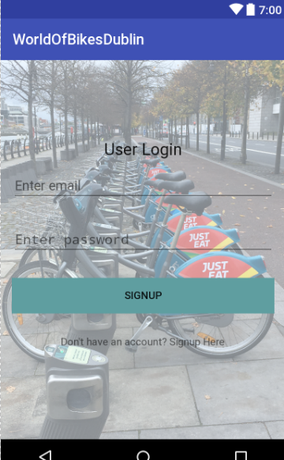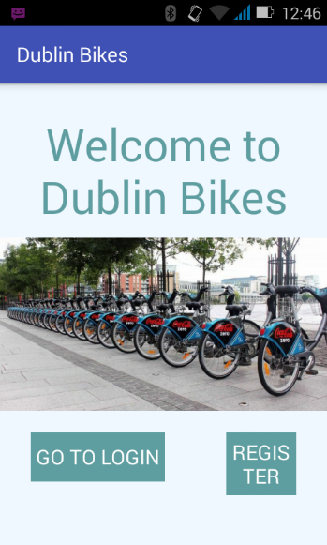

Original start page

## A link to your original prototype

https://github.com/Anne-MarieNamara/DublinBikes.git

## Technologies/Techniques used (may be covered in development approach and cloud services used)

My approach to this was to research the internet for bikes apps. I downloaded a few and looked at how they were put together. Then I drew some designs of what I wanted to be in the app.

I looked at the Coursera example projects we downloaded in class to see which ones I could use the code from. I took code from these apps:

UITabwidget (for the tabs)

MapLocation

HelloWithLogin (for prototype, but then I scrapped it when I used the firebase tutorial)

HelloAndroidWithMenus

I also looked at the grid layout app but decided I wouldn’t use it in the end.

The first version of my app used SQLite so I was using a tutorial from “Android for beginners” for the SQL parts but I found the tutorial confusing and then took the SQL parts out as I thought it would be better to use Firebase instead.

I used the Firebase tutorial for login and register from *SimpleCoding* which is on Youtube.

I followed another Youtube tutorial for putting in the code to take a photo. This was from EDMT Dev.

Some of the photos used were from the internet, and some I took myself in Dublin.

When I had an error, I went online to find answers and usually someone had already asked a similar question on Stack Overflow. Some of the answers worked for me, but a lot of them didn’t match my exact problem. I did many versions of my app. I had to start over several times. One example was when I had downloaded two JSON files and used the incorrect one in my app. Android would not allow me to overwrite or delete the JSON file in my app so I had to start over with a new project and new name, and then copy and paste the code into it.

I tried to put a hamburger menu that would show up on several pages which would connect to the Logout button but I got confused when trying to change the code from the Coursera app HelloAndroidWithMenus to match my app, so it is just on the GalleryActivity now.

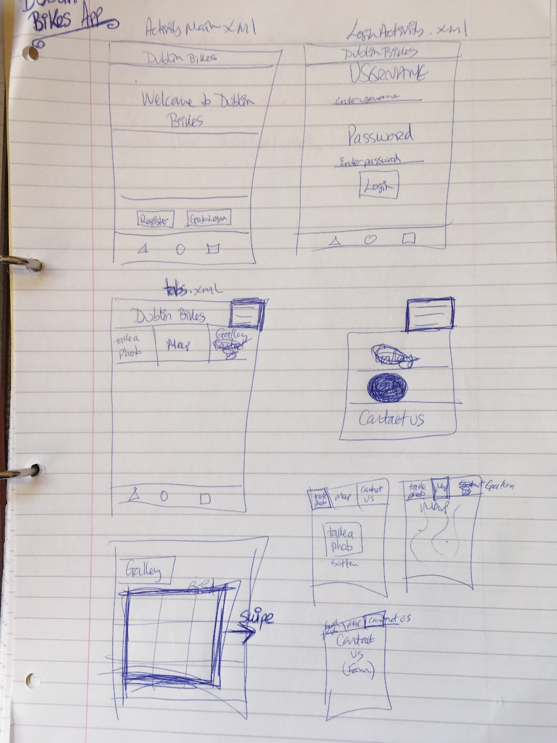

Designs for the app

## Strengths and weaknesses of your Mobile App Application

If the app ran, the strengths would be that it shows the user what the bike stations look like so even if the user didn’t know the area, the bike station could be identified by the photo.

The main weakness of the app is that it doesn’t run. Every time I research and solve an error, it throws up another one. If I had more time, I would start over and leave the firebase until last so that the only errors I would be dealing with would be caused by firebase.

To improve my own weaknesses when it comes to Android development, I think I need to do another Android course that moves quite slowly and with a strong emphasis on error negotiating and fixing. I will do this in my own time and I will take my time to ensure I learn everything correctly.

## References/Bibliography

Horton, John.

*Android Programming for Beginners*

Packt Publishing©2015

Simplified Coding

*Firebase Tutorial*

YouTube published 13th July 2016, accessed 24th Sep 2017

EDMT Dev

*Android Studio Tutorial – Take picture with Camera*

YouTube published 24th Aug 2016 accessed 29th Sep 2017

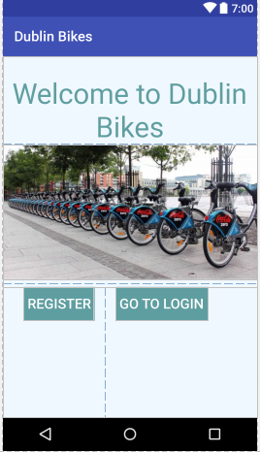Appendix

## *#build1*

The first time I ran it on my Huawei phone, the buttons on the main_activity.xml could not be seen, so I changed the location of them (even though the emlulator nexus 6 was showing the buttons). I had it on Linear layout, then changed it to Relative layout, then changed it back again. I didn’t want to hard code the position on the screen but it was the only way to make them be seen on my phone.

## *#build2 DublinBikes*

<https://github.com/Anne-MarieNamara/DublinBikes.git>

I added in a SQL database and was putting in a function to have a photo taken and stored in the database but when I tried running it, there were errors. I didn’t know how to fix them.

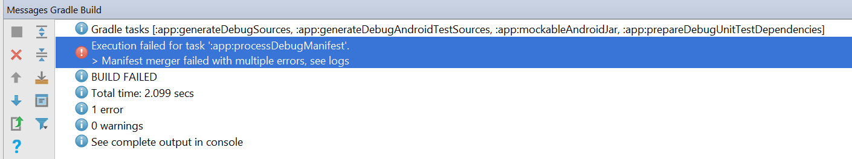

## *#build 3*

I was getting confused with the database tutorial I was using for building the SQLite database so I decided to take it out and use Firebase instead. However I ran into problems once I got as far as using addOnCompleteListener. Android gave me an error message which said that it could not resolve ‘OnCompleteListener’. I searched StackOverFlow for an answer and one that I found said that my firebase auth had to be the same number as my other dependencies.

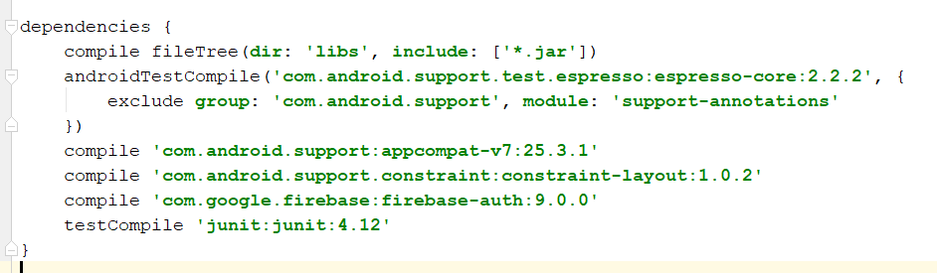

I tried changing all of them to 9.0.0 but that didn’t help. It just made things worse, so I changed them all back, and went back on the internet to find another answer. A second answer I found said that google services had to be 3.0.0 to work with firebase auth 9.0.0 and my google services was 3.1.0 so I changed that and rebuilt the gradle, but an error message showed and said that the JSON was missing so I changed that back to 3.1.0. Then I was stuck and didn’t know how to fix the situation. If I couldn’t get this resolved, then my app wouldn’t run. I ran the app and the monitor said that JSON was missing, so I found where I had pasted it in, deleted it and pasted it in again, but this didn’t solve the problem.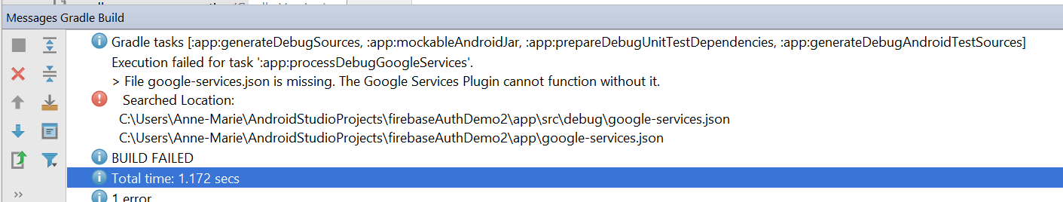

## *#build4*

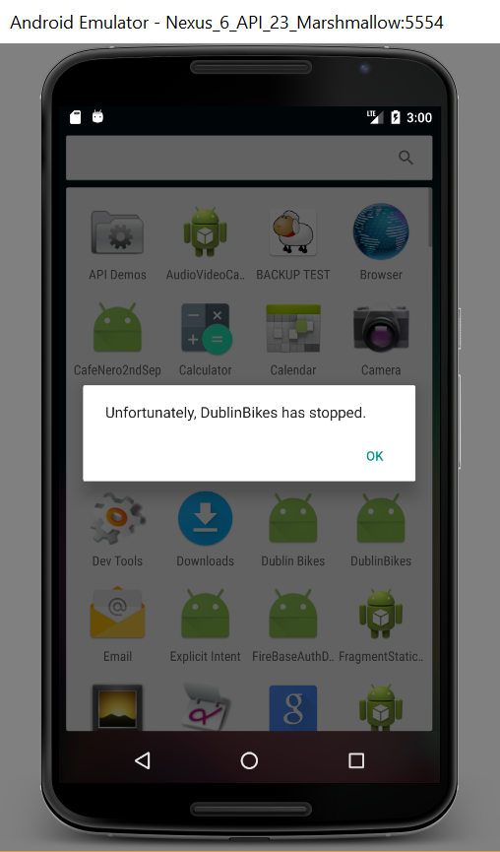

I couldn’t figure out the problem with the firebase Auth so I started a new project and pasted in the xml only to see how that was working but it wouldn’t run at all on the emulator.

I was feeling pretty frustrated at this point.

## *#build 5*

So I realized I’d made a mistake when creating my java classes, (I was creating classes not activities) so I created a new project with the intent to start over. I connected it to Firebase but my manifest file disappeared and I couldn’t figure out how to get it back, I tried a clean build but nothing changed. So I had to delete it from firebase and Android Studio and start over again.

## *#build 6 Renamed BikeWorldDublin*

<https://github.com/Anne-MarieNamara/BikeWorld.git>

While syncing the gradle build after adding in the firebase authentication and google services for this version of my app, I got this error:

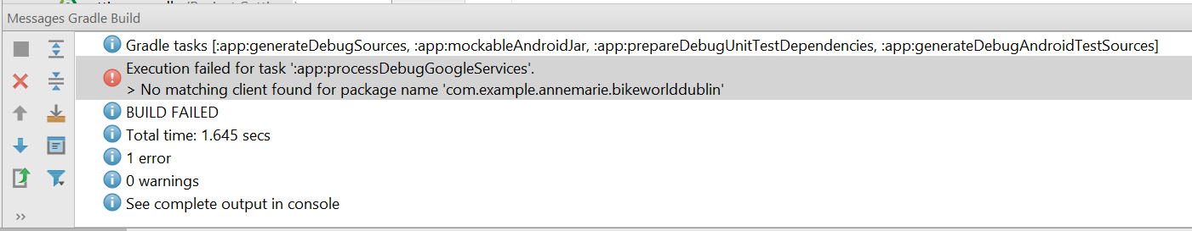

I had already put the package name into Firebase so I didn’t know what the problem was. It turns out I had copied and pasted the incorrect JSON file as I had two of them on my desktop. Android wouldn’t allow me to delete it or overwrite it with the correct one which I got from Firebase, so I had to make a new project and copy all the data in.

## #build 7 Renamed to WorldOfBikesDublin

<https://github.com/Anne-MarieNamara/WorldOfBikes.git>

It’s the ‘:app:processDubugResources’ error which has been stopping the app from running this time. I have run out of time to continue with this project.

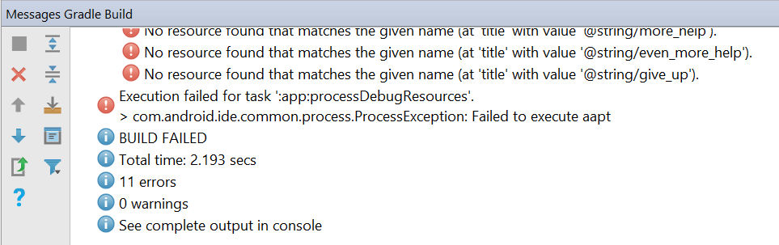

## Anything else that you consider necessary to include

Because the app never ran after I put in the firebase it was very difficult to see how the different pages would connect to each other. I probably should have taken it out and then made the app and then added it back in at the end but I didn’t feel confident doing that as the tutorial I was using added it in at the start.

I would have preferred if we had done a beginner’s Android course as the level of the Coursera course we did was intermediate and it took me a long time to get my head around some of the concepts. I would have learned more if we had created a few apps from scratch in class, instead of opening apps that were made earlier and just amending the code.

This app took much longer to do everything than I thought it would and I did not know enough information about Android to deal with all the errors. I spent 90% of my time searching online for answers to ‘*android cannot resolve’* problems instead of coding.

I do not feel confident using Android Studio because every time I click yes to an update, my emulator stops working. The code prompter doesn’t tell you what each option will do like Visual Studio does, so you have to google them or just guess.